Data Types Refresher:
- Complete the following table:
Data Type | Description | Example
Int | A whole number | 3
Float | A decimal number | 3.14
String | A piece of text | “Elephant”
- Use this pseudocode algorithm to create a working Python program to split a restaurant bill
Print "Welcome to the meal price splitter"
value ← Input "How many people need to pay? "
people ← int(value)
value ← Input "How much was the bill? "
bill ← float(value)
priceEach ← str(bill/people)
Print "Each person should pay " + priceEach
Once you have completed the task paste your code underneath. Then go to the next page.
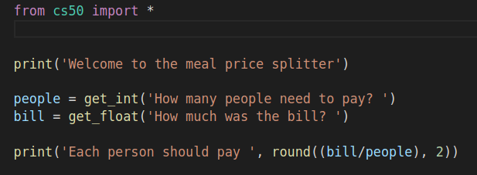

- This program doesn’t work correctly. Use your knowledge of casting and data types to try and fix it. You also need to pick up on the syntax errors in the code.
age = inp("How old are you in years? ")
months = age = 12
days = age + 365
primt("You are around " months " months old.")
primt("You are around + days + days old.")

Once you have completed the task paste your code underneath.
